**Weekly Contribution (Week 5) – 21/03/21**

**Name: Wasif Hossain**

**Student ID: 13227640**

**User Interface & Mockups**

Created and worked on updating the landing page, created login page for mobile, login and registration for desktop and the travel home dashboard page. I also made mockups with Ipad, IPhone, Mac and Laptop for the presentation slides. Giorgio also helped on designing these pages and elements.



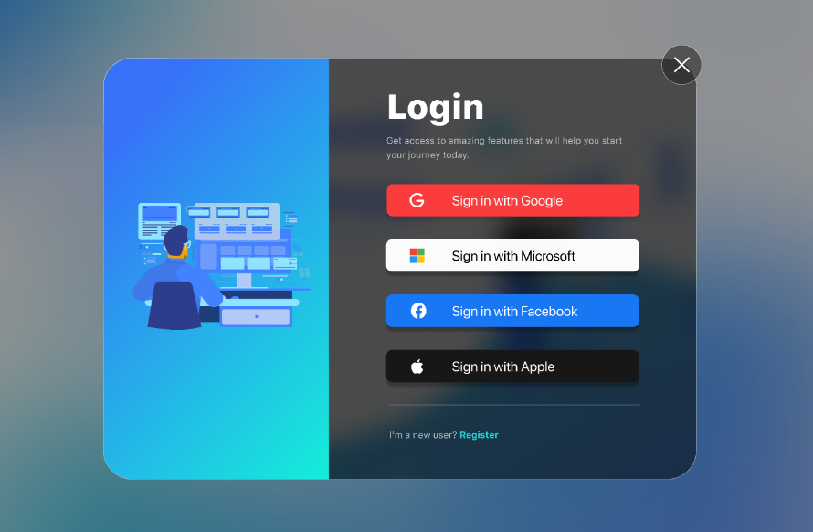

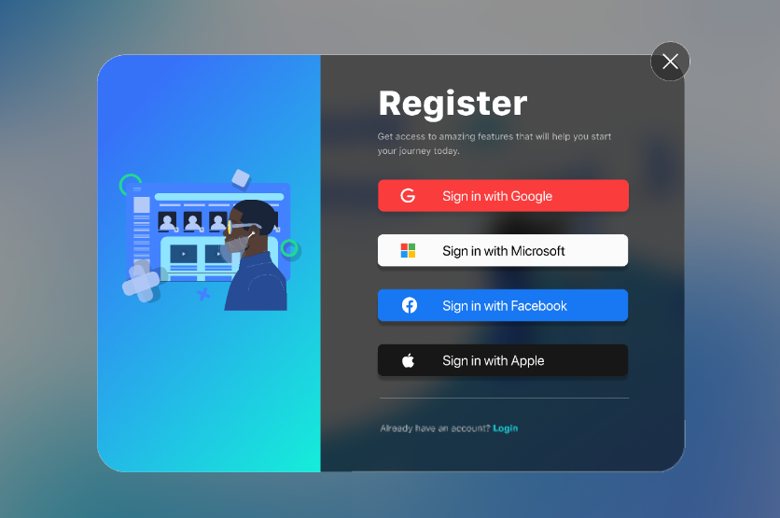

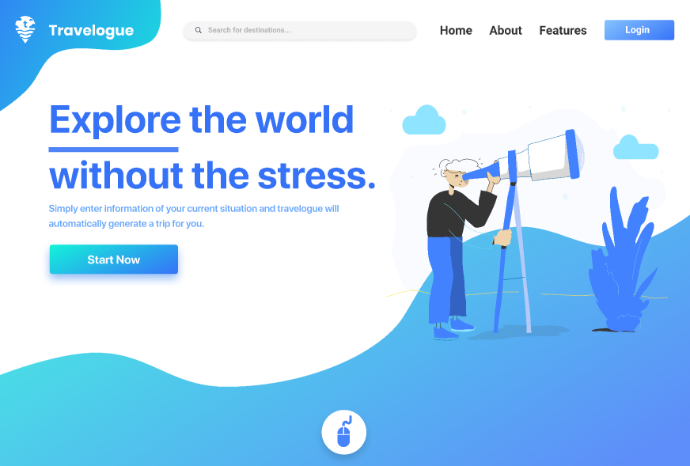

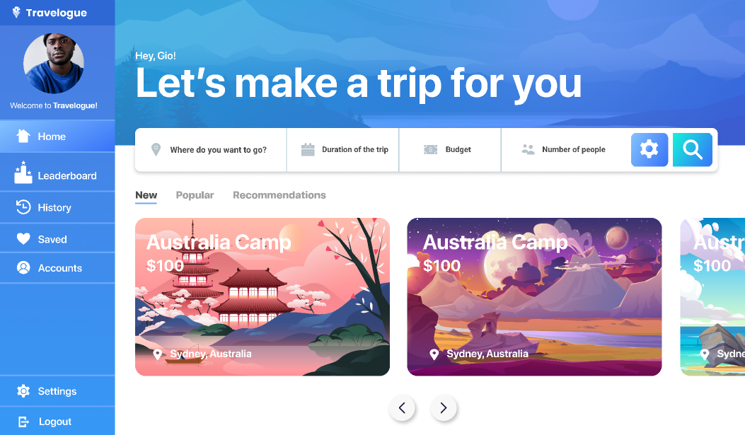

**Contributed to Presentation – Assessment 1**

Contributed to the design and content of the presentation for assessment task 1 and to the following pages below.



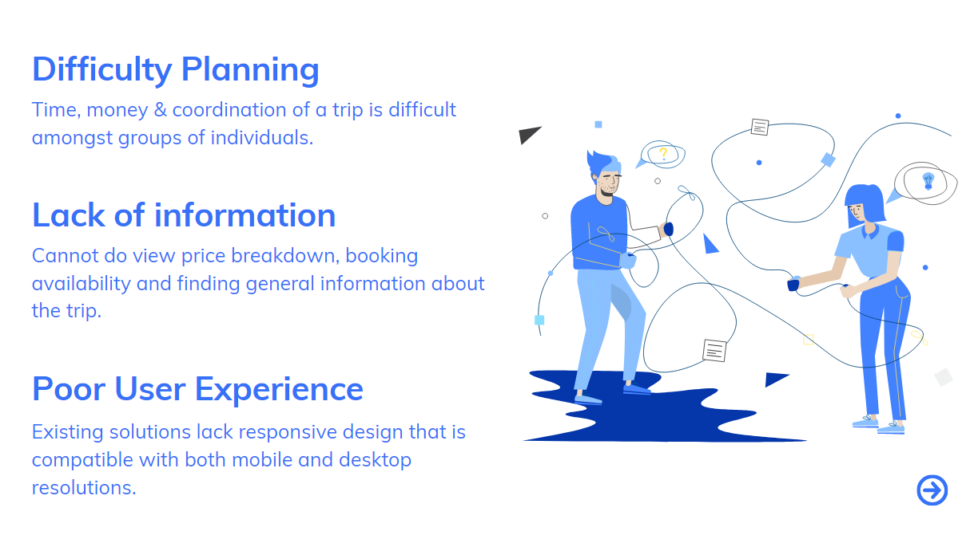





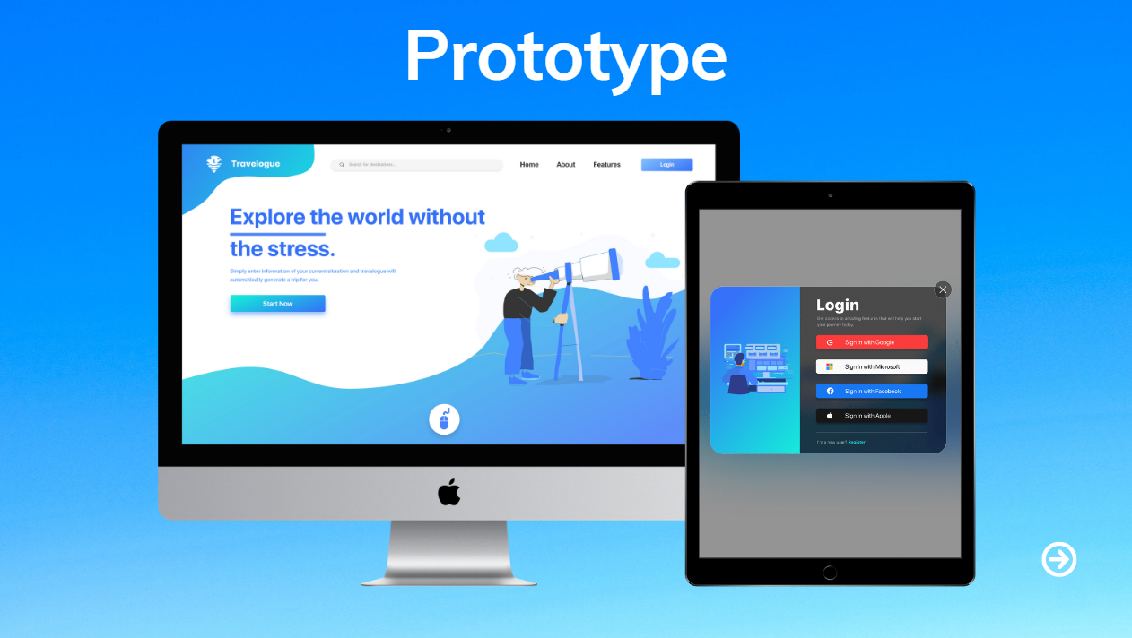

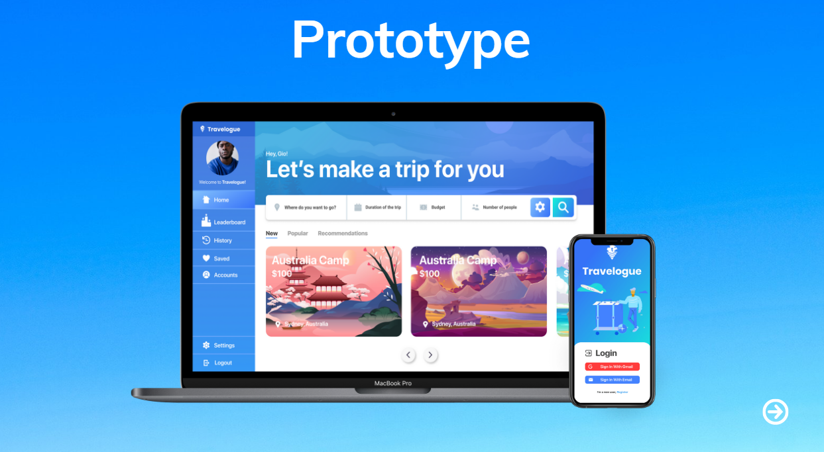

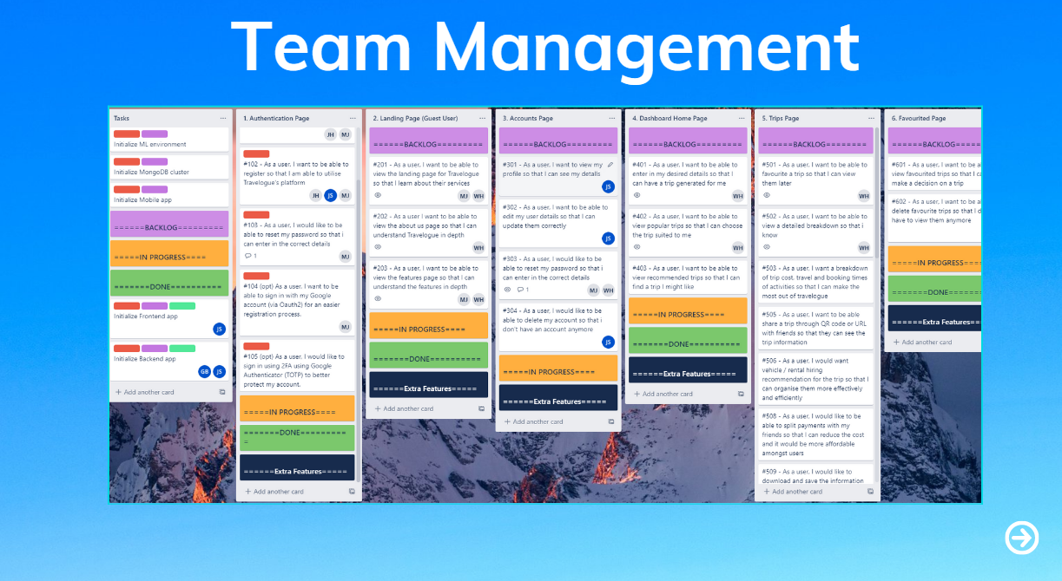



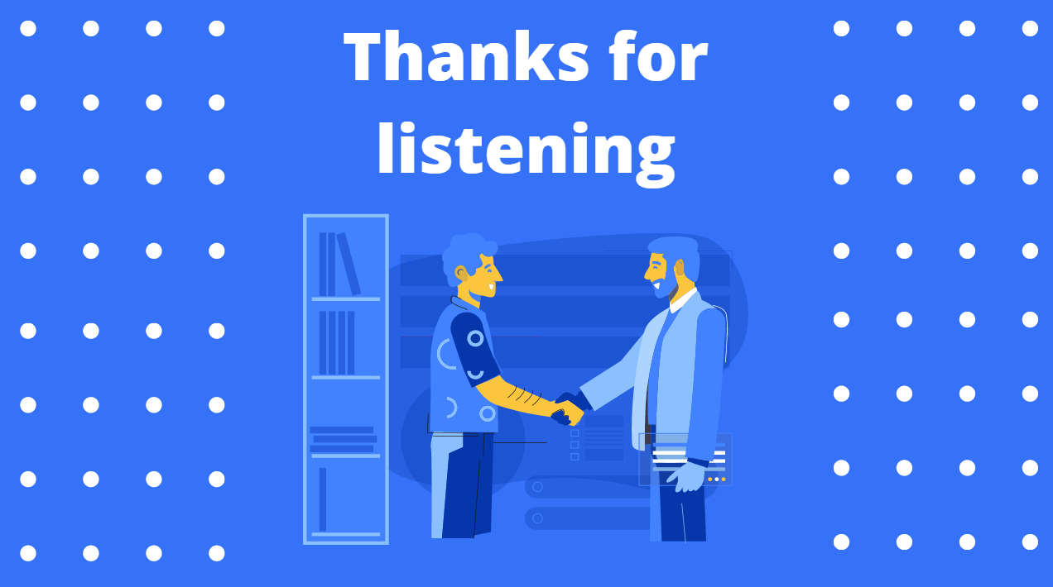

**Development Research**

Studied about Redux and made some notes for the team which has been uploaded as a commit with a hash of: 688880ebb6f9c2c0322c507c5d921d22c8e79445

**Commit URL**: https://github.com/Studio-3A/Front-end/commit/688880ebb6f9c2c0322c507c5d921d22c8e79445

